**Gmail API Setup Instructions**

Go to console.cloud.google.com:

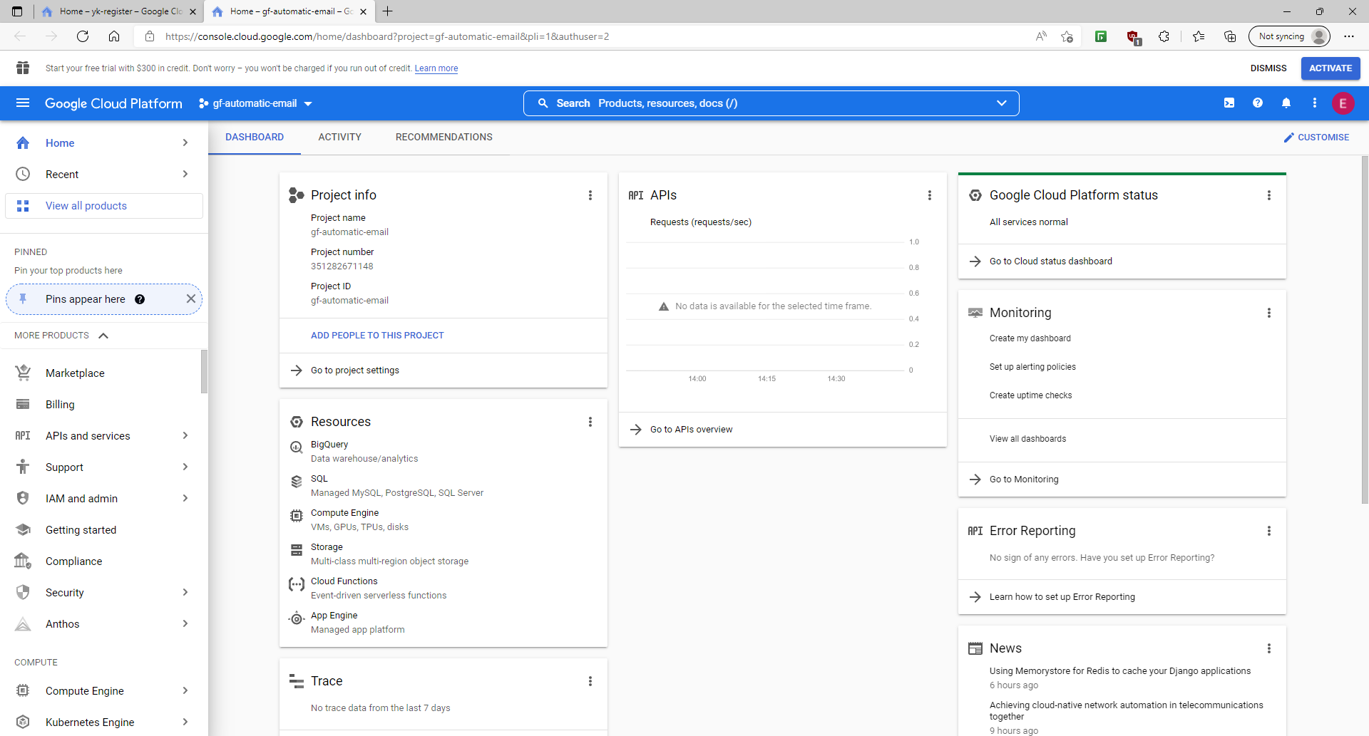

On the left menu:

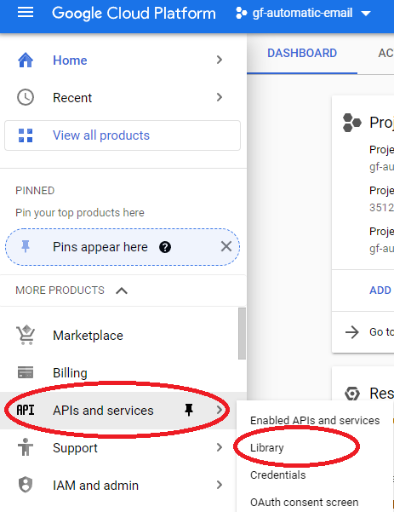

Search for “Gmail API”:

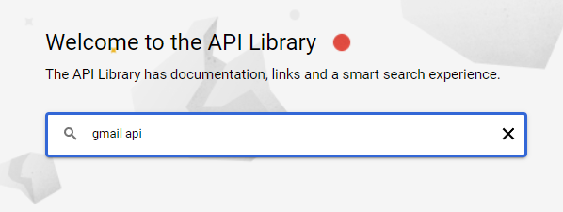

Right here:

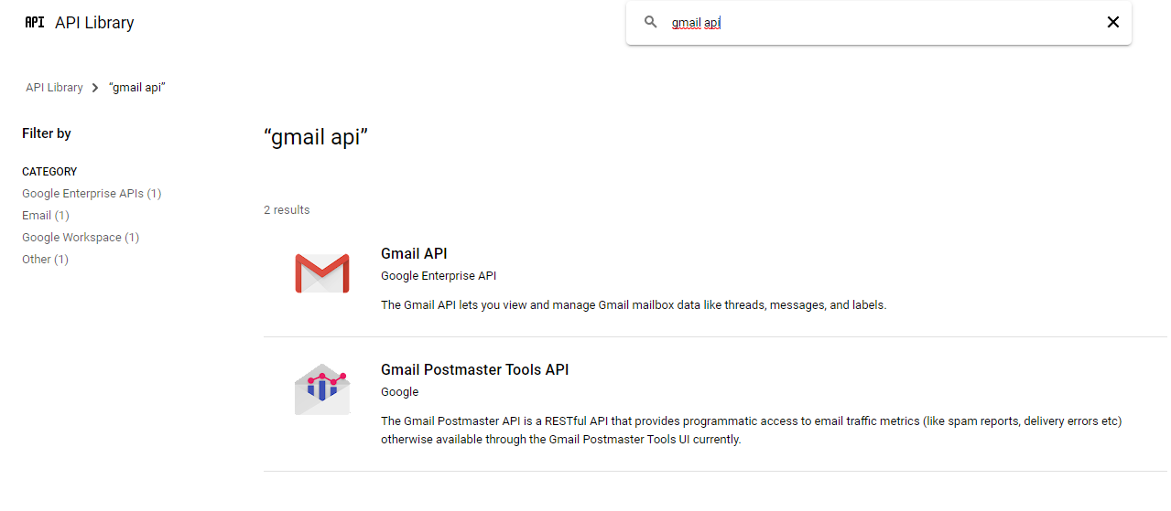

Ensure that the API is enabled, as shown below:

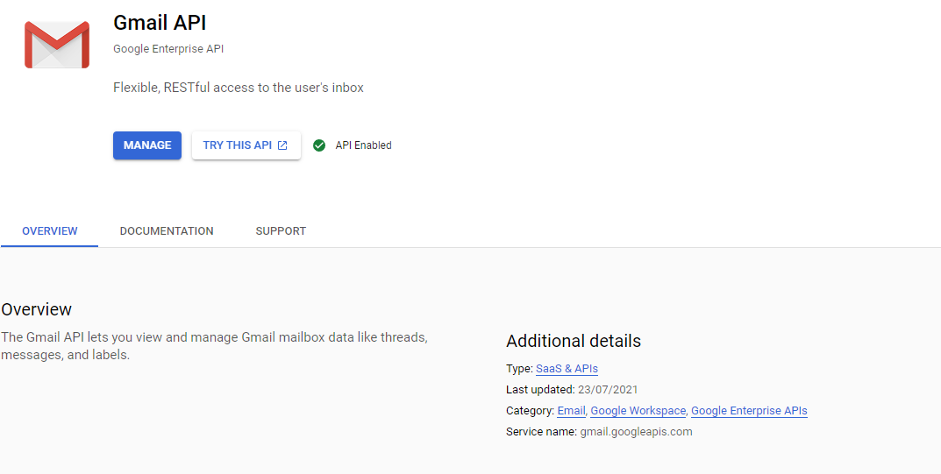

Go back to the navigation pane, click the following:

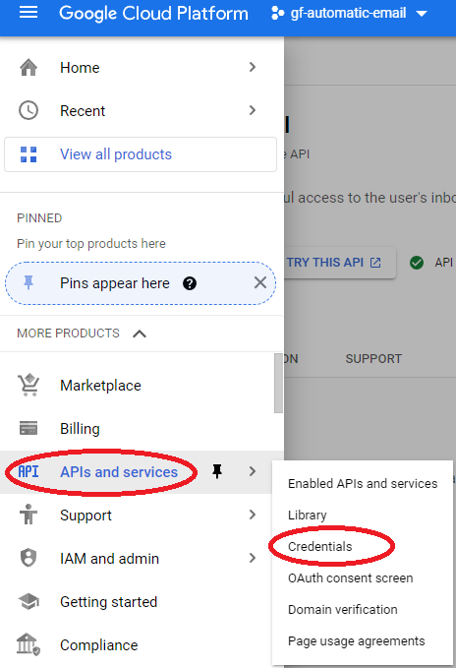

Click on “Create Credentials” > “OAuth client ID”:

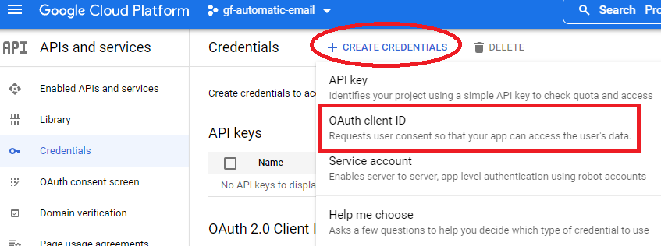

Click “download”



Click “download JSON”

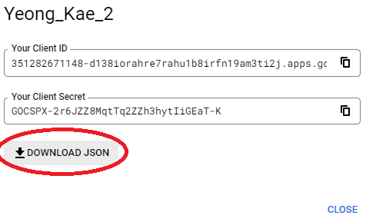

Rename the file!





Move file to location program directory:

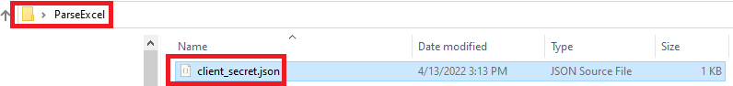

You will be redirected to Google’s login page. Choose “Email Reminder”:

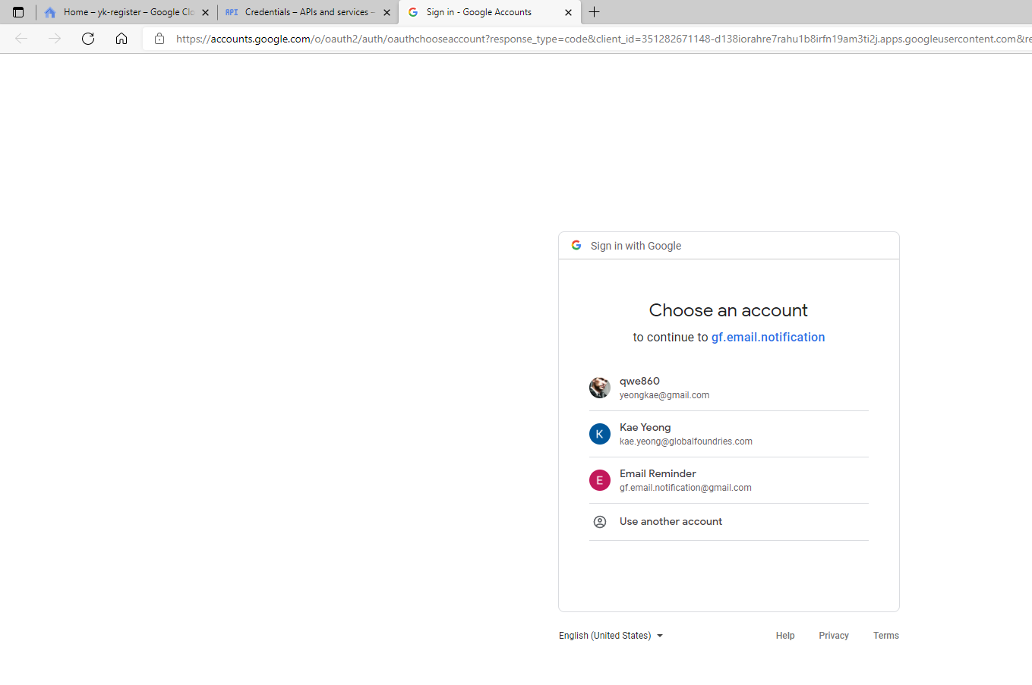

Click “Advanced”

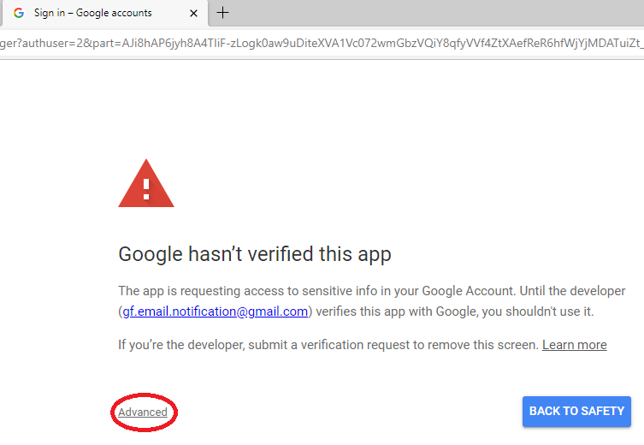

Click on “go to gf.email.notification(unsafe)”

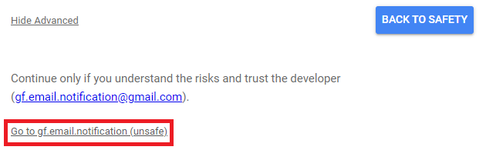

Click “continue”

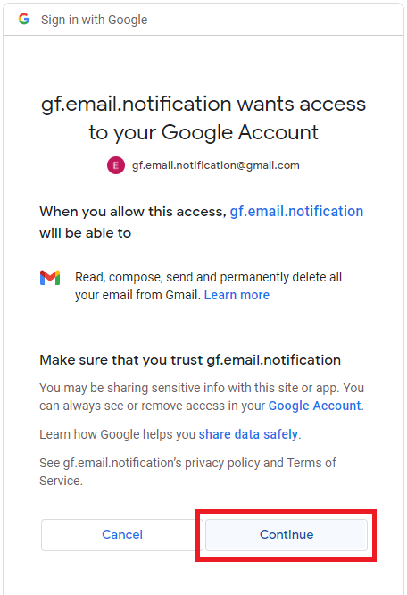

Authentication complete!

